Set up replication rule between AWS S3 buckets

# Introduction

This lab will guide you through the steps to set up a replication rule between two Amazon S3 buckets. By the end of this lab, you will have a source bucket and a target bucket configured for data replication.

# Let’s get started

### Step 1: Log in to AWS Console

1. Open your web browser and navigate to the <https://us-west-2.console.aws.amazon.com/s3/buckets?region=us-west-2&bucketType=general&region=us-west-2>

2. Log in with your AWS account credentials.

### Step 2: Create Source and Target Buckets

1. In the S3 console, click **Create bucket**.

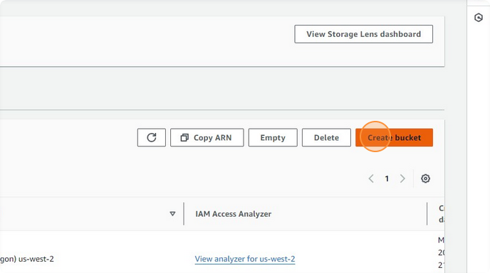

2. In the **Bucket name** field, type `targetbucket`.

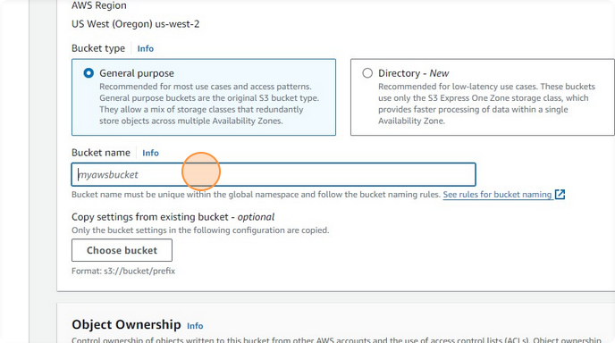

3. Click **Create bucket** to create the target bucket.

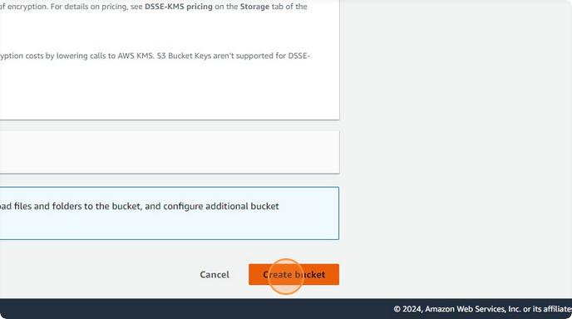

4. Repeat steps 1-3 to create the source bucket:

- **Bucket name**: `repprocess`

### Step 3: Enable Versioning on Source and Target Buckets

1. Navigate to the source bucket (`repprocess`).

2. Click on the **Management** tab.

3. Click **Create replication rule**.

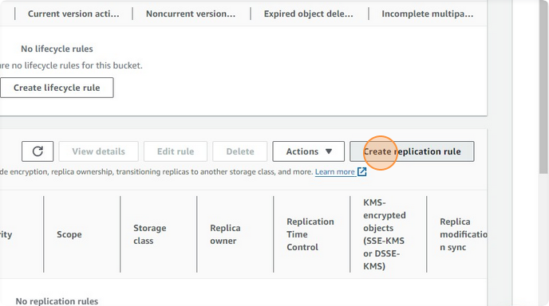

### Step 4: Configure Replication Rule

1. In the **Replication rule name** field, type `bucketreprule`.

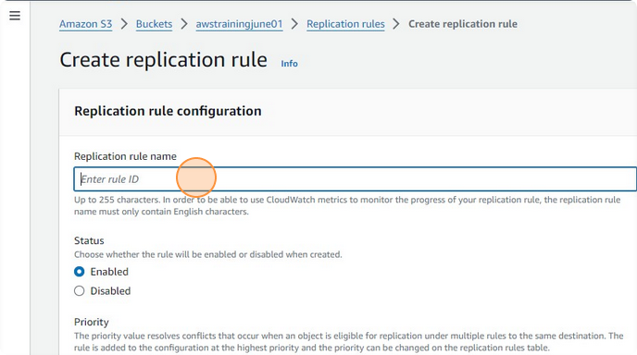

2. Select the option to enable the rule.

3. Click **Browse S3** to select the target bucket.

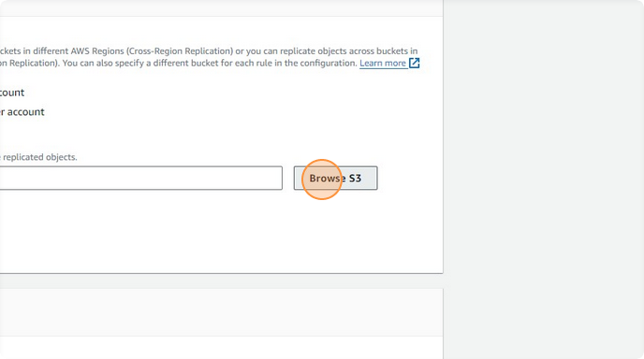

4. Select the **targetbucket** and click **Choose path**.

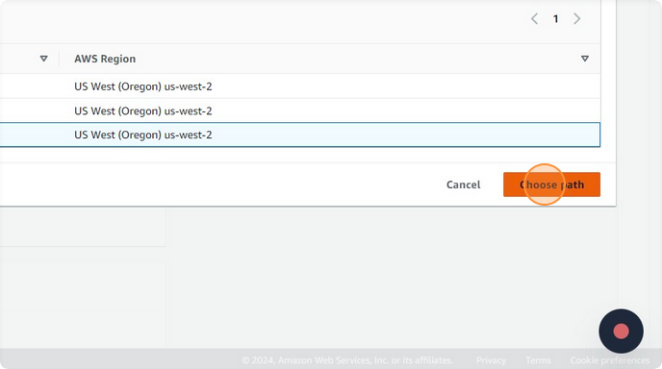

5. Enable **Versioning** by selecting the appropriate option.

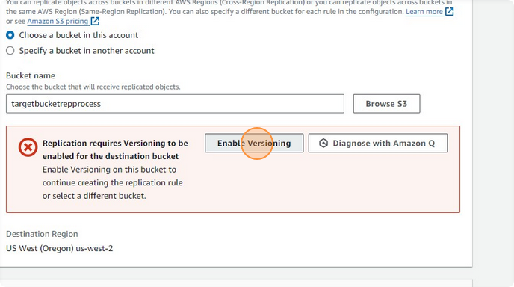

6. Review the **IAM Role** settings, ensuring that the role has the necessary permissions.

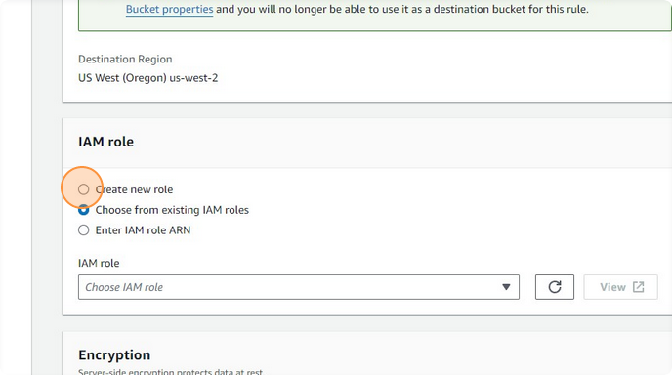

7. Check the required checkboxes to enable replication.

8. Click **Save** to save the replication rule settings.

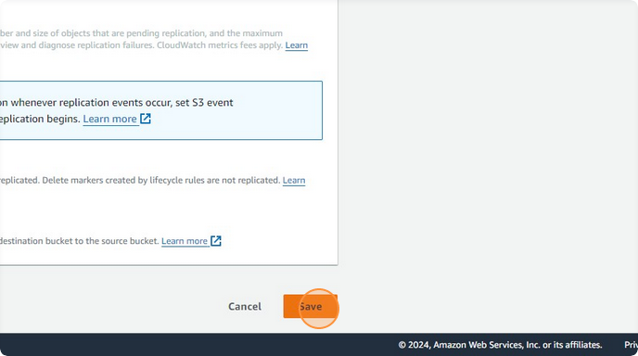

### Step 5: Verify Replication Rule

1. After saving the replication rule, click **View details** to review the rule settings and ensure everything is configured correctly.

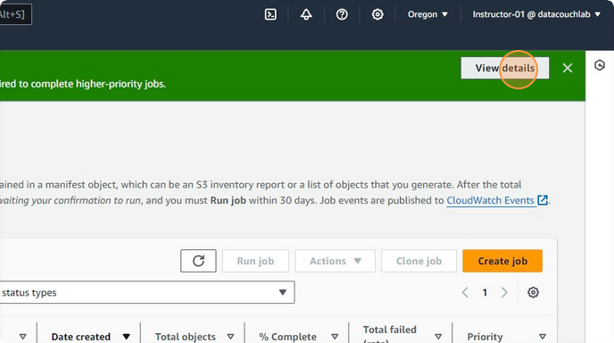

### Step 6: Upload Data to Source Bucket

1. Navigate to the source bucket (`repprocess`).

2. Click **Upload**.

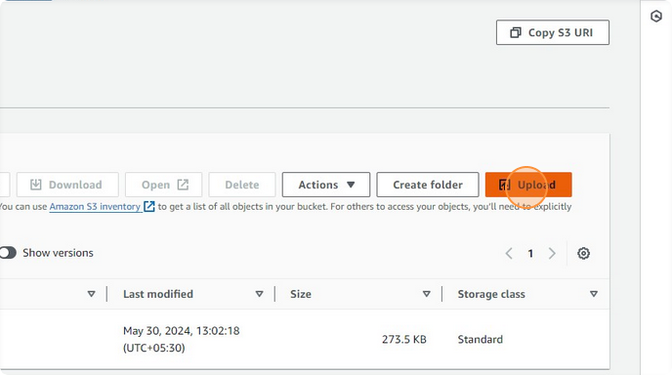

3. Click **Add files** and select the files you want to upload.

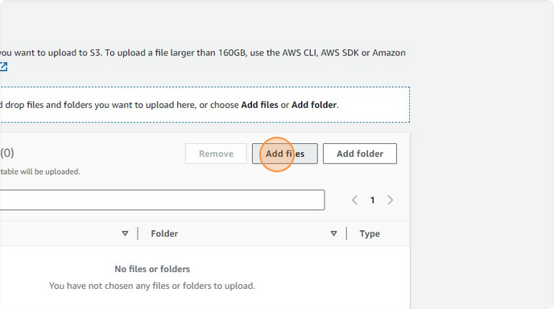

4. Click **Upload** to upload the files to the source bucket.

### 

### Step 7: Verify Data Replication

1. Navigate to the target bucket (`targetbucket`).

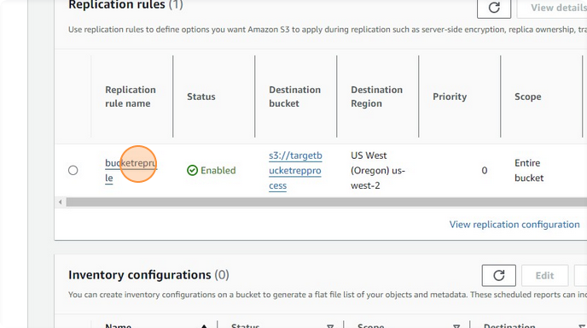

2. Verify that the files uploaded to the source bucket are replicated to the target bucket.

**Voila!!** We have successfully completed this exercise.